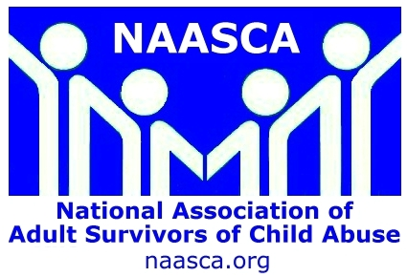
Wearing a Blue Ribbon is a symbol of child abuse and trauma awareness
NAASCA has launched a new child abuse &
trauma awareness program that we call
our FREE BLUE RIBBON Campaign.
We ask everyone to regularly wear this simple symbol of child abuse awareness, and hope all those concerned with public safety, crime reduction, and especially protecting our kids will get involved!
Child abuse is at pandemic proportions in America
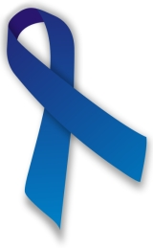
What are the statistics / facts of the abused?
NOTE: “Official” statistics are all considered to be very conservative, since child sexual abuse is among the least reported of crimes. A lot of child sex abuse (CSA) is never known.
The statistics we use are not our own. Updated regularly, they come from the most reputable official reports, and include information from federal government sources, well-established non-profit groups and the best scientific and educational studies.
Regardless, the numbers are all absolutely astonishing! It’s conservatively believed that, in all parts of American society, 1 in 4 girls and 1 in 6 boys WILL BE sexually assaulted before they are 18 years old -- which means 1 in 5 of America's youth, or fully 20% (at the very least) of the population! Obviously once they reach maturity the same proportion of adults among us were sexually traumatized as kids.
Each instance of child sexual abuse is a criminal act, but at NAASCA we're concerned with helping stop ALL kinds of child abuse, including sexual assault, violent or physical abuse, emotional trauma and neglect. The Center for Disease Control (CDC) believes that close to 50% of our youth will experience at least one of these. In its most recent study, done in 2008, the CDC estimated the lifetime cost to society for dealing with all issues related to the child abuse of just one year's worth of traumatized kids is $585 billion, an astonishing figure that obviously repeats each year !!!
Children who tell about being abuse almost never lie, but most either keep the secret or tell one or more inappropriate and / or non-understanding adults, which can delay their getting help for years.
Teaching prevention to kids is an adult responsibility, as is learning the signs of possible abuse and intervening on a child’s behalf. The NAASCA web site’s INTERVENTION RESOURCES has more info.
~~~~~~~~~~~~~~~~~~~~~~~~~~~~~~~~~
NAASCA asks: If you suspect a child is in danger, call 911 in an emergency,
or the www.ChildHelp.org National Child Abuse Hotline at 1-800-4-A-CHILD
24 hours a day, 7 days a week. Together we can make a difference !!
~~~~~~~~~~~~~~~~~~~~~~~~~~~~~~~~~
NAASCA’s FREE BLUE RIBBON Campaign -- some statistics / facts

Did you know these statistics and facts?
There are between 40 and 50 million adult survivors of childhood sexual abuse in America.
Between 2/3 and ninety percent of child sexual abuse (CSA) victims never tell !!!
Over 90% are assaulted by someone they know, love or trust, the majority by members of their own family; true “stranger danger” is very rare.
Some 20% of child sexual abuse victims are under the age of 8, and some don't recall the abuse. Others will later have adult PTSD that can re-awaken these memories.
At least 1 in 7 children who are regular Internet users receives sexual solicitations online, and 1 in 3 is exposed to unwanted sexual material. About 1 in 25 kids receives a request to meet someone in real life that they first encounter online, and think they know.
800,000 children are reported missing every year in the US (about 2,000 every day). Many are runaways trying to escape childhood trauma. An estimated 200,000 are abducted by family members, and 58,000 by non-family, the primary motive for which is sexual assault.
In the most serious cases, a child who’s abducted by a stranger is killed, held for ransom, or taken with the intention of keeping them.
According to the Department of Justice, 74% of abducted children who were later found murdered were killed within 3 hours of being taken, a sign that there must be a quick and effective response to reports of missing children. Every second counts.
In terms of home-based violence:
Some 3.3 million children witness domestic violence in their homes each year. An incredible 1 in 4 women and 1 in 9 men will experience domestic violence in their lifetime -- 1 in 5 teen girls and 1 in 10 teen boys are victims of dating violence.
Children exposed to violence are more likely to abuse drugs and alcohol. Traumatized kids may suffer from deep depression, anxiety or panic attacks, and post-traumatic disorders. Many have difficulty in school and some become delinquent, engaging in criminal behavior.
Sixty percent of American children are exposed to violence, crime, or abuse in their homes, schools, and communities. Almost 40% of American children are direct victims of 2 or more violent acts, and 1 in 10 are victims of violence 5 or more times.
Children are more likely to be exposed to violence and crime than adults. About 1 in 10 American children see one family member assault another family member, and more than 25% are exposed to family violence during their life.
A child’s exposure to one type of child abuse and trauma greatly increases the likelihood that the child will be exposed to other types, too .. and exposed multiple times.
Please wear a FREE BLUE RIBBON as often as you can, and encourage others to do so, too. Together we can do what we cannot do alone. Help us help our kids !!

