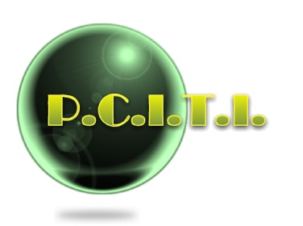
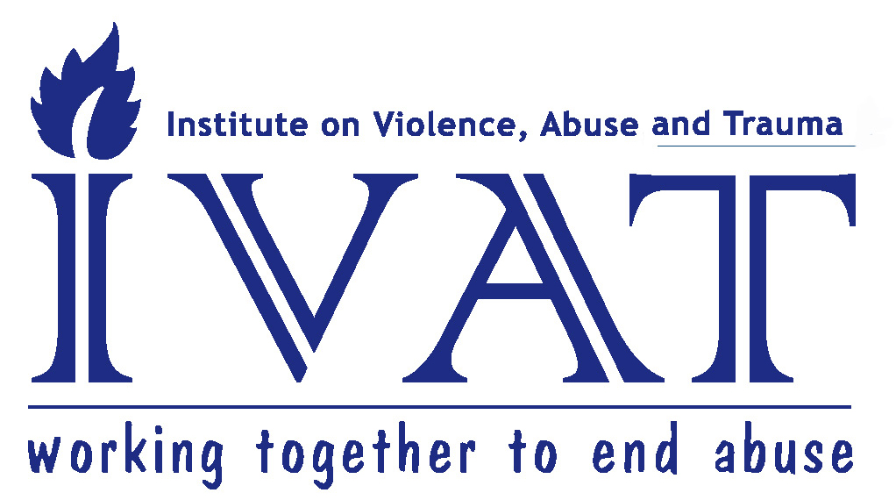
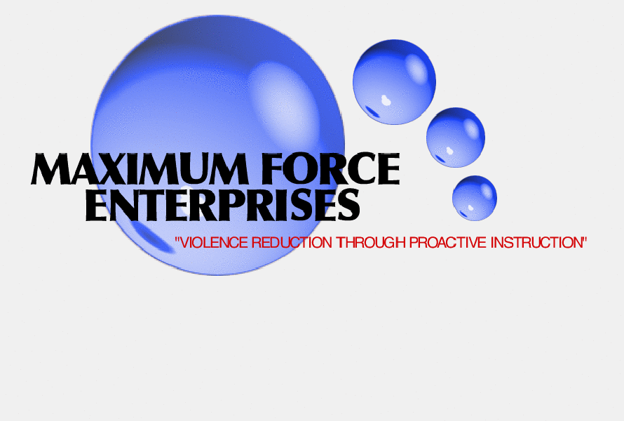
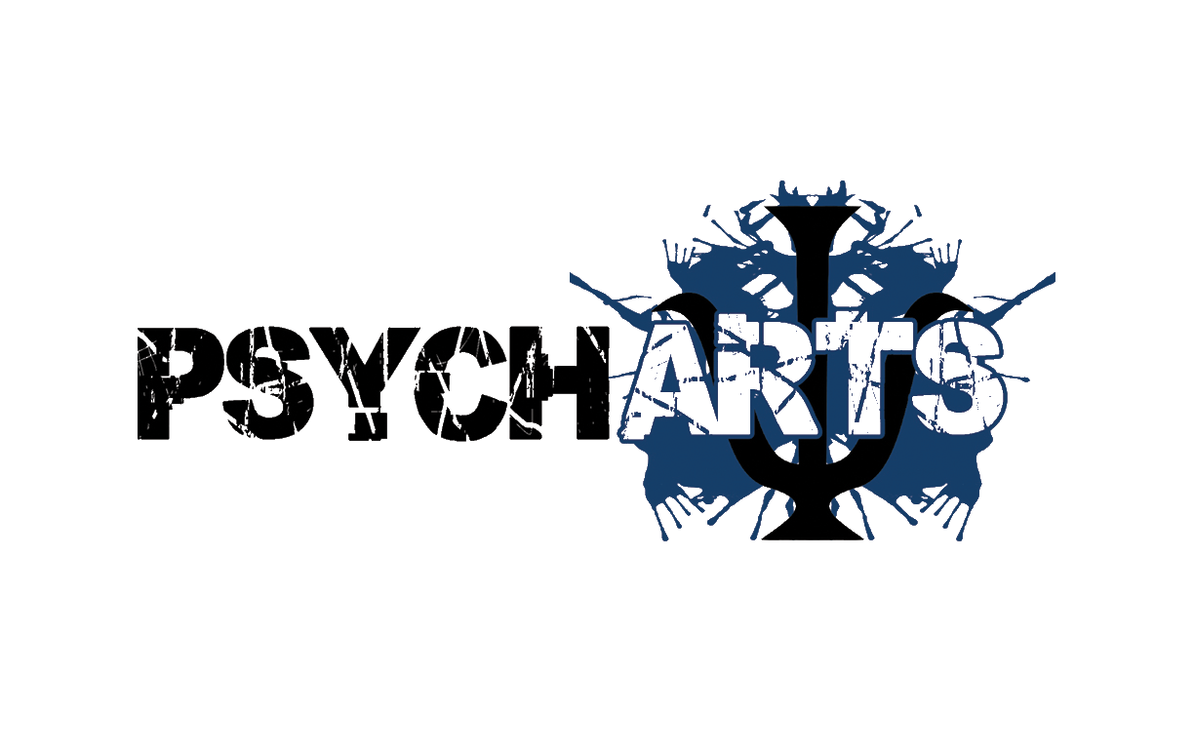

Continue Education

Opening Ceremony
July 16th 1 hour, 9:00am-10:00am
Debra Warner, Psy.D. Aquil Basheer, Commander William Scott
The opening ceremony will discuss the nature of the first annual SCRIPT conference and this year’s theme of Stop the Stigma. The conference opener will have speakers from the community and keynote speaker William Scott from the South Bureau LAPD.

Learning Objectives
- Participants will be able to define male violence and abuse.
- Participants will be able to define trauma related to male violence and abuse.
- Participants will be able to discuss the connection as it related to violence and abuse as it related to male survivors.
- Participants will be able to discuss possible solutions to issues related to violence and abuse related to male survivors.

Keynote Panel, Stop the Stigma: Male Trauma and Violence
July 16th 2 hours, 10:00am-12:00pm
Debra Warner, Psy.D. Moderator

This panel will discuss male violence and abuse and its connection to the community. Community representatives from law enforcement, academia and the community will be a part. Panelist questions will include:

- What is the stigma related to Male Survivor Trauma?
- How does the sigma effect survivors lives?
- Are the emotional responses that are connected to survivor trauma?
- What can the community do to Stop the Stigma?

Question and answer will follow panelist discussion.

Learning Objectives
- Participants will be able to identify 3 types of stigma that effects survivors lives.
- Participants will be able to identify 3 unique emotional responses related to male survivors of trauma and violence.
- Participants will be able to identify 3 specific steps the community can take to reduce stigma related to male survivors of violence and abuse.

Barriers to Education for People of Color
July 16th 1 hour, 10:00am-11:00am
Augustine Panchoo, Psy.D., Professor of Psychology

Today, most parents and their children believe that a college degree is necessary for obtaining stable and meaningful work (Schneider and Stevenson, 1999). This attitude is reflected in the educational expectations parents hold for their children and in the expectations that young people have for themselves (U.S. Department of Education, 1995b, p. 88). High educational expectations can be found among all racial and ethnic groups regardless of their economic and social resources (p. 73). Although parents and children share high educational aims, their aspirations do not necessarily translate into postsecondary matriculation. This is especially the case for Hispanic and Black high school students, particularly those whose parents have not attended college (Nuñez, Cuccaro-Alamin, and Carroll, 1998).

According to the U.S Census Bureau (2003) despite high educational expectations among persons over 25 years old show that only 11% of Hispanics and 17 % of Blacks compared to 30% Whites and 49% Asians have attained a bachelor’s degree. Even more troubling, more than one-fourth of Hispanic adults have less than a ninth-grade education (U.S. Census Bureau, 2002b).

Literature suggests that the underrepresentation of people of color in STEM (Science, Technology, Engineering & Mathematics) fields is linked to both structural barriers in educational access and opportunity, and social/psychological barriers and responses to disparities and social stigmatization (STEM; Bureau of Labor Statistics, 2009; U.S. Department of Commerce, 2011).

As a cumulative effect of these barriers, African American and Latino students demonstrate much lower proficiency rates in science and mathematics than their White and Asian peers (National Center for Education Statistics, 2011, 2012), are less likely to access and achieve success in advanced coursework (College Board, 2012), and demonstrate lower levels of college readiness than their peers (ACT, 2011; SAT, 2011). These K-12 outcomes have significant implications for STEM persistence in higher education and degree completion, where just 22% of Latino students and 18% of African American students who aspired to major in a STEM field complete a Bachelor’s Degree in STEM within 5 years (Eagan et al., 2010).

Learning Objectives:
- To teach how to address barriers in a more direct and decisive way and seek services for academic achievement.
- Participants will be able to develop 3 strategies for overcoming learning barriers.
- Participants will be able to develop 3 strategies to assist students and parents on how to become knowledgeable regarding students success
- Participants will be able to develop 3 strategies to assist students and parents on how to become knowledgeable regarding student academic achievement.

Vocational Issues Related to Male Survivors of Trauma and Violence
July 16th 2 hours, 1:00pm-3:00pm
Ed Mashek, M.A.

This panel will focus on vocational issues that relate to survivors of violence and trauma. The panel discusses community supports needed along with professional applied examples to crystalize information. Questions include:

1. Thinking about the themes of this conference what are some unique issues that male survivors face relating to trauma and violence?

2. How can we as individuals support the male survivor with these issues?

3. How can we and a community support the male survivor with these issues?

4. What is it that we as a community miss in supporting and assisting male survivors?

Question and answer will follow panelist discussion.

Learning Objectives:
- To teach vocational issues that relate to survivors of violence and trauma.
- Participants will be able to identify 3 strategies for supporting male survivors of violence and trauma with vocational issues.
- Participants will be able to identify 3 strategies to assist professional dealing with male survivors of violence and trauma in a vocational setting.
- Participants will be gain knowledge about community resources available to support professionals and male survivors of violence and trauma.

Effectively Engaging with Male Survivors of Sexual Abuse
July 16th 2 hours, 2:00pm-4:00pm
Christopher M. Anderson

This presentation gives an overview of the unique challenges male survivors face, the harmful myths that discourage both boys and men from coming forward, and presents best practices for supporting their healing. The presenter is a resilient survivor of childhood sexual abuse in addition to other childhood trauma. The material is appropriate for both professional and lay audiences.

Learning Objectives:
- Participants will be able to identify 3 emotional/psychological sequelae of abuse.
- Participants will be able to identify 3 unique harmful messages that are commonly heard
by male survivors of sexual victimization and will understand how they impede healing.
- Participants will be able to identify 4 specific suggestions for facilitating more effective interacting with male survivors of sexual abuse.
- Participants will be able to identify 3 specific elements that are keys to healing from abuse and trauma.

BPT: Believe, Stay Present, “Thank You” - A Trauma Informed Response to Disclosures of Abuse
July 17th 1 hour, 9:00am-10:00am
Christopher M. Anderson

Many survivors report it is very difficult to find safe persons to whom they can feel comfortable disclosing their experiences of victimization. Men and boys who disclose are often scorned, or worse yet targeted for further victimization. Women and girls are often asked what they did to make themselves more vulnerable. And as many survivors of crime and abuse struggle to come to terms with their pain all too often they meet with professionals who ask, “What is wrong with you” as opposed to “What was done to you?” This presentation will review some important concepts about trauma, and the potential impact of trauma on the brains, bodies, and behaviors of survivors of abuse and trauma. Armed with these concepts we will review a simple model that will give professionals from any field and lay persons the concepts required to provide a compassionate and empowering response to any disclosure of trauma. The presenter is a resilient survivor of childhood sexual abuse in addition to other childhood trauma and has trained thousands of professionals on the dynamics of male sexual victimization. The material is appropriate for both professional and lay audiences.

Learning Objectives:
- Participants will be able to identify 3 basic structures in the brain and basic concepts about their role and function in cognition and regulation of bodily systems
- Participants will be able to identify 3 unique harmful messages that are commonly heard
by male survivors of sexual victimization and will understand how they impede healing
- Participants will be able to identify 3 specific steps that are keys to providing a
compassionate and empowering response to disclosures of trauma and abuse
- Participants will be able to identify 3 specific elements that are keys to healing from
abuse and trauma

And the Trauma Goes On …
July 16 and 17
2 hours each day, total of 4 hours, 1:00pm-3:00pm the 16th and 10:00pm-12pm the 17th

Judy Matthews, PsyD, Brandman University

Trauma is unfortunately and remarkably common in the modern world. At least 40% of adults have been exposed to a traumatic life event. The prevalence of PTSD is also considerably high with an overall life time rate on 8% in the United States. Since 1996 the United States has been deporting thousands of veterans who were permanent legal residents when they entered the military. This was due to crimes committed after their service in the U. S. fighting for their country. Often these crimes are a direct result of undiagnosed PTSD from fighting in a war to serve their country. At other times, they have experienced trauma in their childhood before entering the military as a result of environmental events. This presentation will explore the ongoing trauma of these deportees and the need for better diagnosis and treatment of PTSD.

Learning Objectives:
- Participants will be able to define PTSD and Trauma among US Veterans.
- Participants will be able to define the link to PTSD and Trauma among US Veteran populations.
- Participants will be able to learn about recidivism as it relates to undiagnosed PTSD.
- Participants will be able to lean 2 applied learning tools for therapeutic treatment.

Stop the Stigma: A Round Table Discussion Focusing on Violence and Trauma
July 17th 2 hour, 9:00am-11:00am
Moderator Debra Warner, Psy.D.
This discussion focuses on examining many perspectives related to male violence and trauma. The talk will be open forum and open microphone for the community to address issues related to violence and trauma connected to males from multicultural and diversity perspective. Questions will be posed to leaders and experts in the comiummity with a Q/A occurring simultaneously. Questions are below.

- What do you think will change to assist in lower violence and trauma in our community related to male survivors?
- What does change look like?
- What has been effective in making change?
- What has not been effective in making change?
- Who are the one most effected if we do not change?

Learning Objectives;
  - Participants will be able to identify 3soultions to issues concerning violence and trauma related to male survivors.
  - Participants will be able to identify 2 community based strategies that can assist with solutions identified.
  - Participants will be able to identify 3 next steps to implementing change.

Pharmacological Applications to Treat Impulse and Anger Control
July 17th 3 hours, 1:00pm to 3pm
Richard S. Sinacola, Ph.D.

Anger, aggression, irritability, and compulsive actions present as some of the more troubling symptoms experienced by our patients. While depression and substance abuse are the most common presenting issues and cost millions every year in lost wages and productivity, violence, anger and aggression have escalated to include horrific acts against society in the form of terrorism and gun related mass homicide against innocent victims.

To better understand how to treat these individuals and design preventative programs to reduce violence and aggressive behaviors in society, we need to study both the biological, pharmacological, and behavioral approaches most likely to lead to reductions in both compulsive behaviors and aggressive behaviors with individuals and various population groups.

This two hour presentation will provide a brief overview of DSM disorders of aggression and compulsion and provide a summary of therapeutic and pharmacologic treatment available to treat them.

Goals and objectives:
1. To define the types of disorders known as Impulse Control Disorders or ICDs.
2. Provide a summary over-view of diagnostic and behavioral manifestations of each disorder.
3. Present various treatment approaches to each disorder from a therapeutic and pharmacologic viewpoint.

10 Things Partners of Male Survivors of Sexual Abuse Should Know
July 17th 2 hour, 1:00pm-3:00pm
Christopher M. Anderson

This session is a facilitated conversation during which participants will be encouraged to engage with 10 key concepts regarding the ways in which the sexual abuse of a male partner can dramatically alter the dynamics of an intimate partnership. The presenter is a resilient survivor of childhood sexual abuse and other traumas. He has extensive experience training professional and lay audiences on the unique dynamics of male sexual victimization and has facilitated many conversations on this subject matter.

Learning Objectives:
- Participants will be able to identify 5 common areas of conflict that arise within intimate relationships where at least one partner is a male survivor of sexual abuse.
- Participants will be able to identify 5 concepts that will help them reframe common points of conflict within intimate relationships where at least one partner is a male survivor of sexual abuse.
- Participants will be able to identify at least 3 conflict resolution techniques which will
allow them to better assist persons within intimate relationships where at least one
partner is a male survivor of sexual abuse.

"The Importance of Being Selfish"
July 17th 1 hour, 1:00pm-2:00pm
Raymond Nourmand, Ph.D.
Often we're told being selfish is bad. It's disrespectful, shameful, and wrong. But we are all selfish. True selfishness takes courage. It requires we be honest with ourselves in ways many of us might not be used to. Such honesty appears to give rise to the happiest relationships. Implications for therapists will be covered.

Learning Objectives:
1. Understand what true selfishness is.
2. Appreciate how society makes it challenging for people to be truly selfish.
3. Recognize unique obstacles men face in society with respect to becoming truly selfish.
4. Identify how a therapist's own level of selfishness can affect the way he/she conducts therapy.

Closing Ceremony
July 17th 1 hour, 3:00pm-4:00pm
Debra Warner, Psy.D. Aquil Basheer
The closing ceremony will discuss the nature of the first annual SCRIPT conference and this year’s theme of Sop the Stigma. The conference closer will discuss highlights and the future direction of SCRIPT. Speakers from the community and conference partners will speak.
Learning Objectives
- Participants will be able to redefine male violence and abuse.
- Participants will be able to redefine trauma related to male violence and abuse.
- Participants will be able to discuss the connection as it related to violence and abuse as it related to male survivors.
- Participants will be able to label possible solutions to issues related to violence and abuse related to male survivors.

Continue Education is available through the Institute of Violence and Trauma (IVAT) for a $75 Flat Rate. This conference is co-sponsored by The Institute on Violence, Abuse and Trauma (IVAT) at Alliant International University. IVAT is approved by the American Psychological Association (APA) to sponsor continuing education for psychologists. IVAT maintains responsibility for this continuing education program and its content. IVAT is approved by the CA Board of Behavioral Sciences (PCE #33) to offer continuing education for LCSWs, MFTs, and Social Workers. This training meets the qualifications for up to 14.0 hours of continuing education for MFTs, LCSWs, Psychologist and Social Workers as required by the CA Board of Behavioral Sciences. IVAT is approved by the California Board of Registered Nurses to offer continuing education for nurses (CEP #13737). IVAT is approved by the State Bar of California to offer Minimum Continuing Legal Education for attorneys (#11600). IVAT is approved by the California Association of Alcoholism & Drug Abuse Counselors (CAADAC) to offer continuing education for certified alcohol and drug counselors (Provider #1S-03-499-0217). CE credits approved by CA agencies are accepted in most states.
For information on continuing education, contact psmith@alliant.edu

